# Lab 12: Introduction to Design of Experiments (Chapter 7)

## Objectives

* Familiarize yourself with terms relevant to DOE
* Learn how to create your own DOE with your own data in JMP
* Analyze existing data using full-factorial designs in JMP

## Design of Experiments

## Up to now, it has been (relatively) manageable to analyze our data, using ANOVA or linear regression to look at data with only a few factors that has been provided to us. As engineers, however, we will look at data with many different factors that could cover a wide range of values; therefore, it is important to be able to design your experiments so you can easily determine which parameters are significant and which are not. This leads us to our next topic, design of experiments (DOE). Using an effective DOE strategy allows us to run the fewest number of experiments to determine which parameters are significant, and what model we can use to relate our data.

## Terminology

A quick summary of some terms having to do with DOE:

* **Factor** - This is a variable which can be set to a specified value. Also called independent variables, or X values.
* **Response** - This is a variable which it typically measured. The value of the response is typically affected by the factors, making it the dependent or Y variable.
* **Screening experiments** - A Design of Experiments to determine which factors are the most important or significant to the response variable.
* **Levels**  - We select particular values of a factor to test. The number of different values we allow a factor to take is called the number of levels for that factor.
* **Factorial experiment** - An experimental design that tests all possible combinations of the levels of the factors once.
* **2k factorial design** - a factorial experiment where all k factors have 2 levels.
* replicates - Sometimes running 2k experiments is not enough, so we run the full set of experiments multiple times. Each time we run a design experiment is called a replicate.
* **Main effect** - A measure of the effect a factor has by itself on the response. This is represented by capital letter corresponding to the factor. (e.g. A, B, C...)
* **Interaction** - A measure of how two or more factors affect the response together. This is represented by the capital letters of the factors involved printed together. (e.g. AB, AC, BC...) ***Whenever an interaction term is significant, all main effects and lower order interactions that make up the significant interaction are automatically considered significant.***

## DOE: Your Own Data

To create a DOE from scratch, select DOE > Full Factorial Design, from the menu bar or the starter screen.

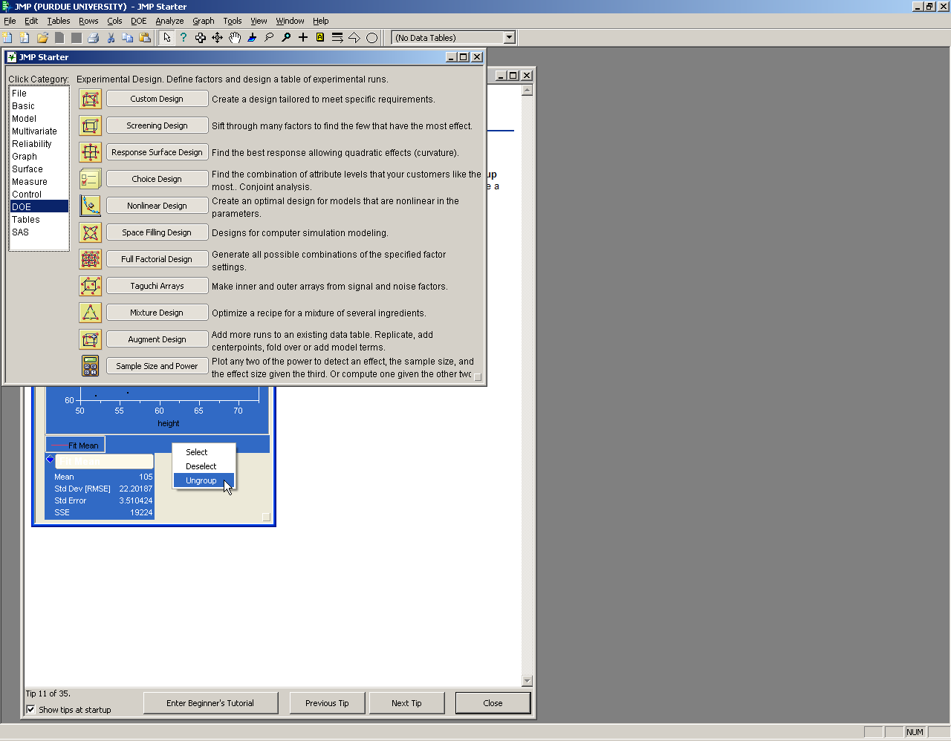

JMP automatically includes your response variable (y), and then you can add your factors (x) by clicking Continuous > 2 Level. In general, we will consider 2 levels of a factor: a high level (+1) and a low level (-1) but in the future, if you want to include more levels (say, +1, 0, and -1) you can choose more levels. Note that in JMP, you can leave the high/low levels at +1/-1, even though in your actual data your high/low could be anything like 0/25°C or 0/1 bar – it doesn’t matter what the actual high/low levels are, just that they are the highest and lowest values.

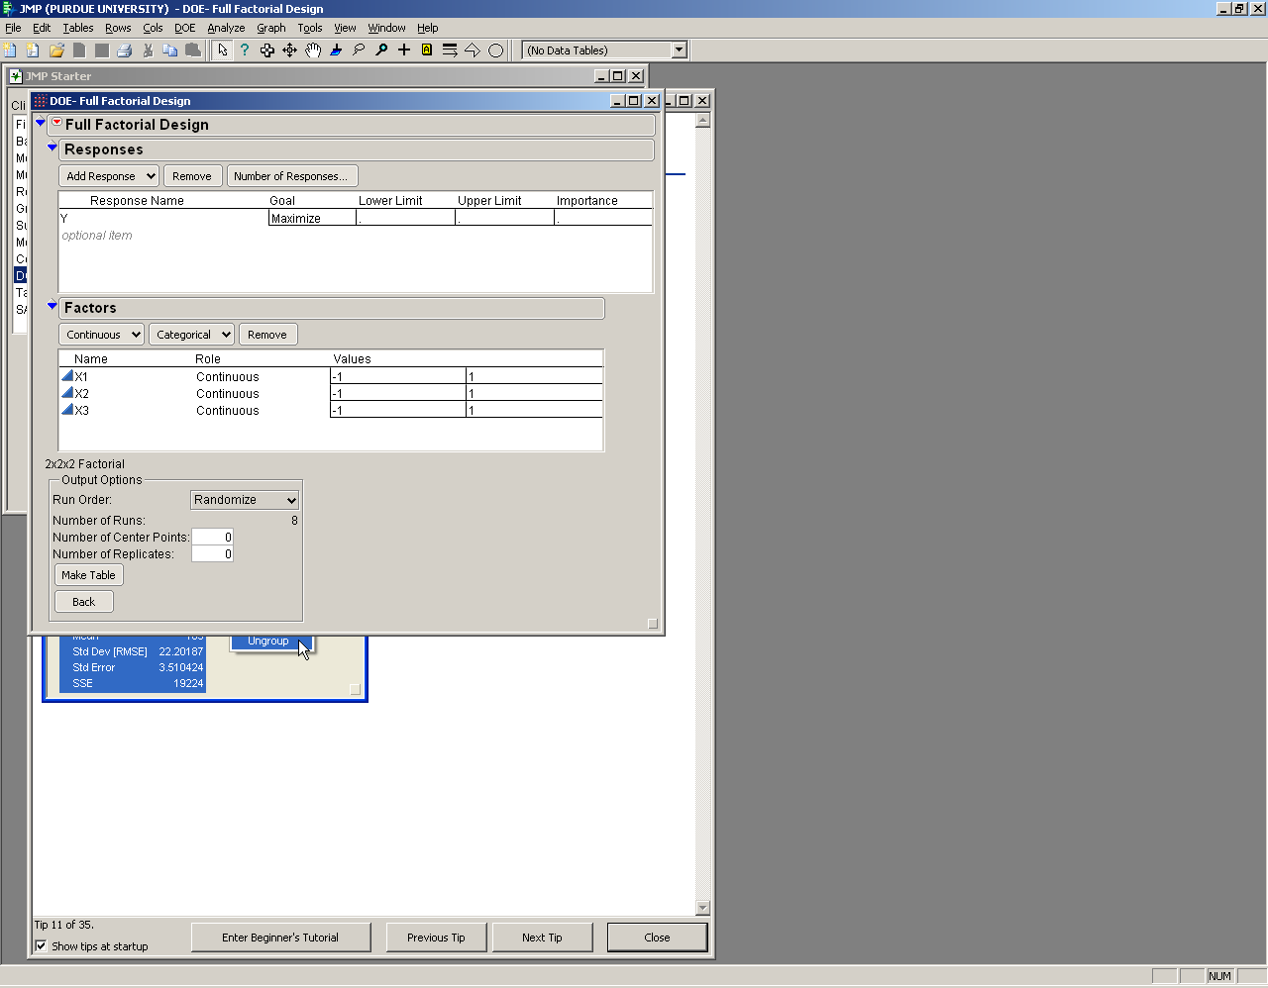

JMP also allows you to select if you want to include center points (generally it can be useful to include 0-2 center points or so to help consider mid-range data instead of just the high and low levels of a factor). You can also include replicates, which means you are running each experiment more than once – usually we will not use replicates because they are costly and typically not necessary, but if you are running an experiment with 3 or less factors, it may be beneficial. Click “Make Table” to create your DOE.

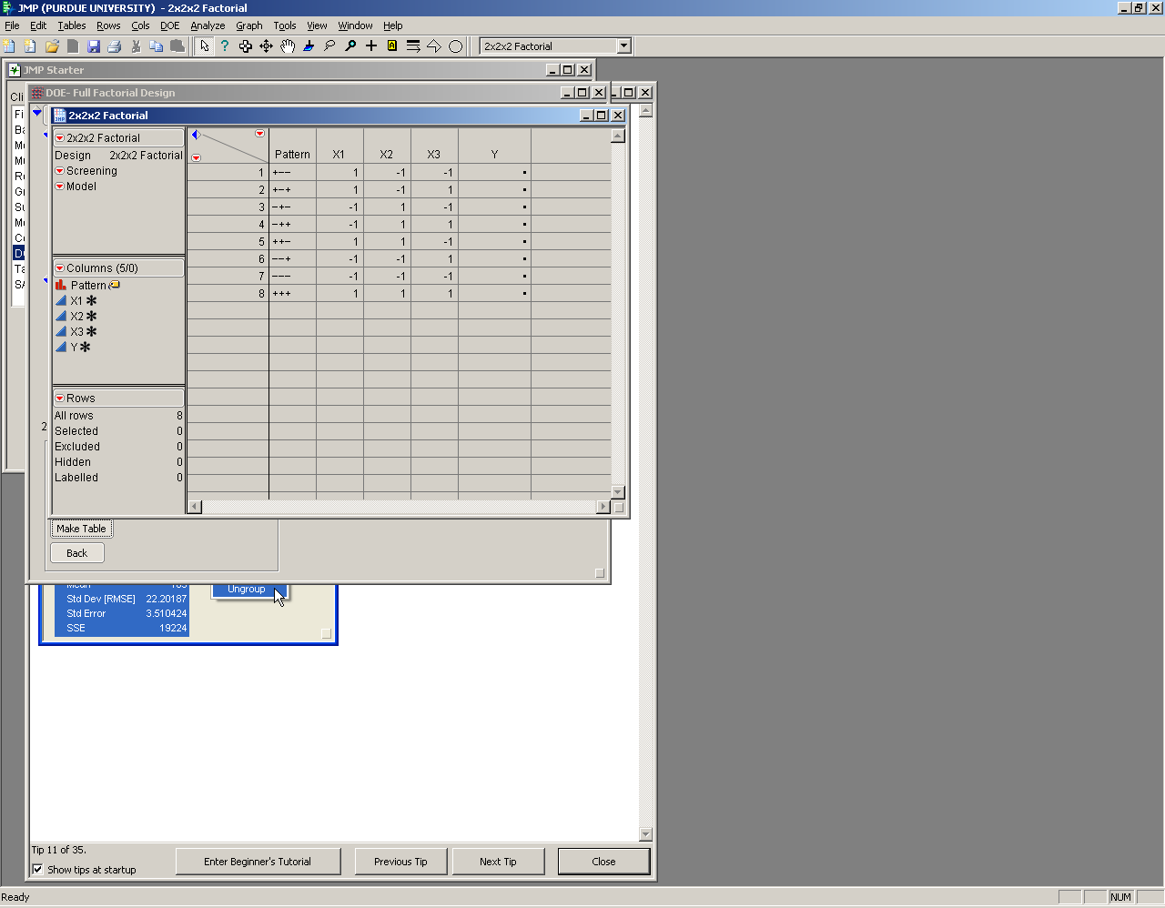

## DOE: Analyzing Existing Data

You can also use JMP to load existing data and analyze that using a full-factorial design. Load your data in JMP, then click Analyze > Run Model. Put your response and factors in the appropriate boxes, then click Macros > Full Factorial. This automatically inserts all of the interaction effects into the model effects box. Then click Run Model.

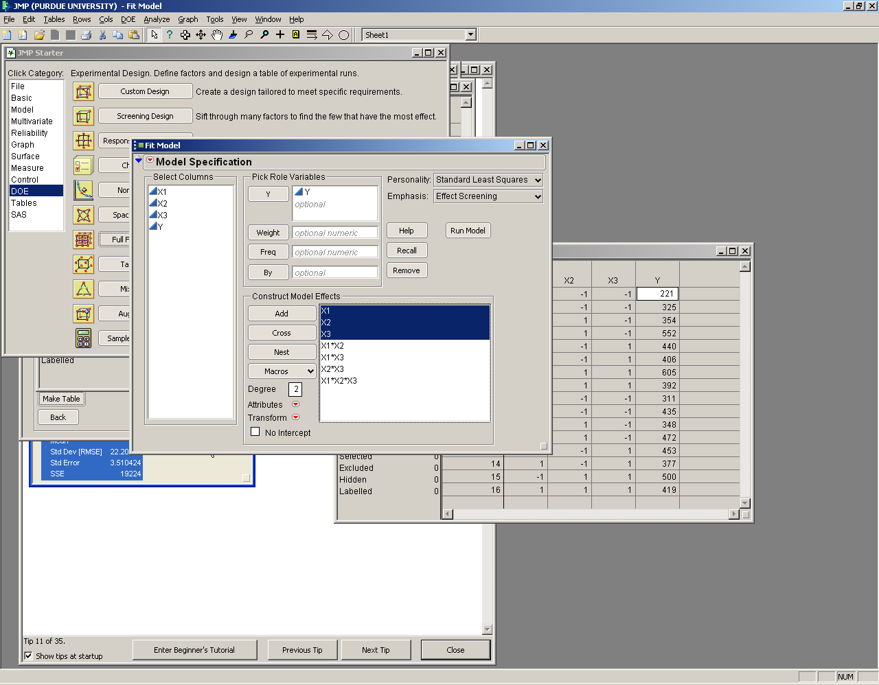

JMP outputs a lot of data you are already familiar with: summary of fit, ANOVA tables, parameter estimates along with their significance level. It now also includes prediction profiles which relate your response variable to each factor. You can also add on interaction plots (click the red triangle next to response, then click Factor Profiling > Interaction Plots) which show how your response relates to each interaction effect. If the lines on the interaction profile are intersecting and non-parallel, that means there *is* an interaction between the two factors in that interaction effect, and thus the effect is significant.

## Lab 12 Exercises

Using the data from exercise 7-13 in the textbook uploaded to Blackboard, answer the following questions.

1. What is the response variable?
2. How many factors are involved in the data set?
3. How many levels does each factor have?
4. How many replicates of the factorial experiment were performed?
5. After running the analysis, which main effects and interactions are significant at α = 0.05?
6. Show and discuss the interaction plots.
7. What is the regression model?
8. Do you include the insignificant terms in the regression model?
9. Analyze the residuals.

What is difference between Effect summary p value and parameter estimates p value?